Why Host with Sautech?
Sautech Hosting Services
Smart, Scalable, Secure – Hosting Built for Performance and Peace of Mind
At Sautech, we don’t just offer hosting—we engineer resilient, secure, and intelligent infrastructure solutions designed to power your business through uncertainty. With more than two decades of experience and a presence in three purpose-built data centers, we deliver unmatched performance, redun- dancy, and disaster recovery.
Our hosting backbone is trusted by companies across South Africa, Namibia, and parts of Europe, with a growing client base that depends on us for speed, compliance, and business continuity.

Unmatched Hosting Infrastructure
3-Tier Data Center Network
We operate from three data centers—two in South Africa and one in Windhoek, Namibia—ensuring:
- Redundancy
- Cross-border compliance
- Regional speed optimization
- Data sovereignty
Advanced Backup Strategy
Unlike conventional hosts, Sautech combines:
- Hot (Live) Replication
- Cold (ONine) Backups
- Data-Specific Recovery Snapshots
- All under one seamless backup policy that’s automated and centrally managed.
Backups can be restored:
- To our DCs
- To third-party DCs
- To on-premise locations
- As entire virtual machines in case of disaster or failure
Portability & DC Mobility
Clients can move workloads between our data centers or restore to third-party facilities without vendor lock-in, giving you true control of your IT assets.
Only Dell Infrastructure
We exclusively use Dell enterprise-grade hardware:
- Proven stability and performance
- World-class support contracts
- Certified compatibility with Microsoft and leading hypervisors
- Because business-critical environments deserve better than generic hardware

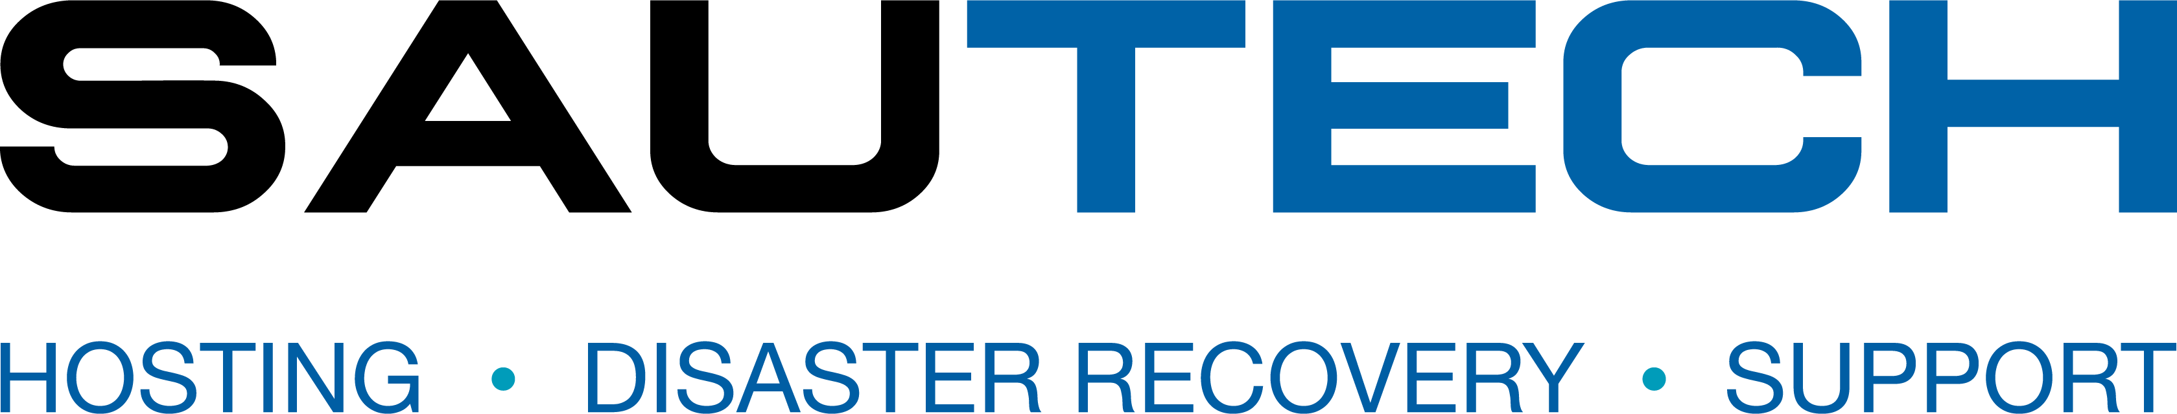




Flexibility, Affordability & Simplicity
- Pricing from only R125/month
- No contracts — scale as needed
- Easy onboarding with step-by-step guidance
- Direct Hosting or Partnered Services
o We work alongside your existing IT provider or software vendors to deliver hosted infrastructure, disaster recovery, and managed backups

We Partner with the Best
- Microsoft SPLA Partner: Rent Microsoft licenses at a fraction of the cost
- SentinelOne: Endpoint protection AI with rollback & ransomware prevention
- CheckPoint Firewall: Tier-1 network and cloud perimeter protection
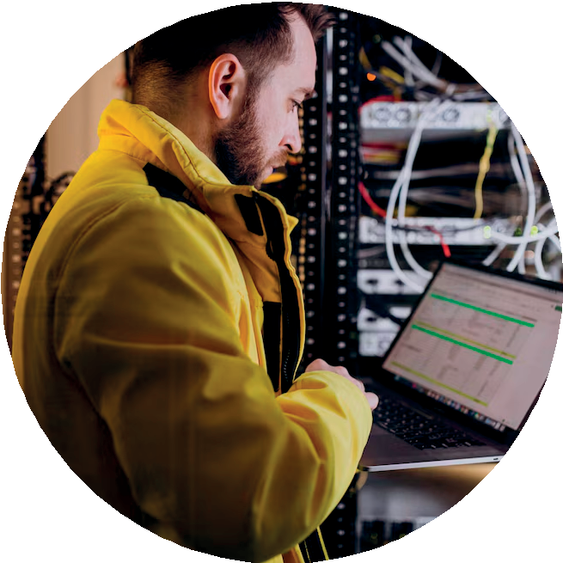
- Dell: Global leader in enterprise server reliability

Specialized SQL Licensing Model
Unlike other providers who force you to rent entire SQL Server VMs, Sautech offers per-database or per-instance licensing, saving you:

- Time
- Money
- Complex setup headaches

This model gives you enterprise SQL hosting with:

- Built-in redundancy
- High-speed access
- Cost efficiency Why Businesses Trust Sautech
- Track Record: 20+ years with zero major infrastructure failure
- Compliance Built-In: RSA & Namibia-based for POPIA, data residency, and latency
- High Availability: Built-in replication, failover, and monitored backups
- Security: Fully integrated cybersecurity stack (SentinelOne, CheckPoint)
- Customer-Centric: Personalized service with enterprise-level expertise

Let’s Talk Hosting That Works for You
Whether you're a startup, a growing business, or an enterprise that needs compliance-ready infrastructure with full disaster recovery — Sautech is your trusted hosting partner.
South Africa – 34 Stokroos Avenue, Krugersdorp Namibia – Erf 740A Liszt Street, Windhoek
+27 11 768 1790 (RSA) | +264 66 347 6685 (NAM)
support@sautech.net www.sautech.net

